# **Data Driven Strategic Decision Making**

## Introduction

This is a social network graph of mutually liked Facebook Pages. This data about facebook pages was collected in November 2017 and I got this data from network repository website (GEMSEC: Graph Embedding with Self Clustering, 2019)([https://networkrepository.com/fb-pages-politician.php](https://www.google.com/url?q=https%3A%2F%2Fnetworkrepository.com%2Ffb-pages-politician.php)). The dataset represents blue verified Facebook pages network categories. Each node represents a page while edges represent the mutual likes between them. The code and the project link is in the github (Indranil, 2025), [Indranil3001/Indranil3001 at Data-Driven-strategic-Decision-making](https://github.com/Indranil3001/Indranil3001/tree/Data-Driven-strategic-Decision-making)

## Network Structure and Visualisation

From the initial analysis of the network, we can see that the network is highly connected. The total number of pages or **nodes are 5908** while the mutual likes or **edges are 41729**.

The real network visualization looks like this:

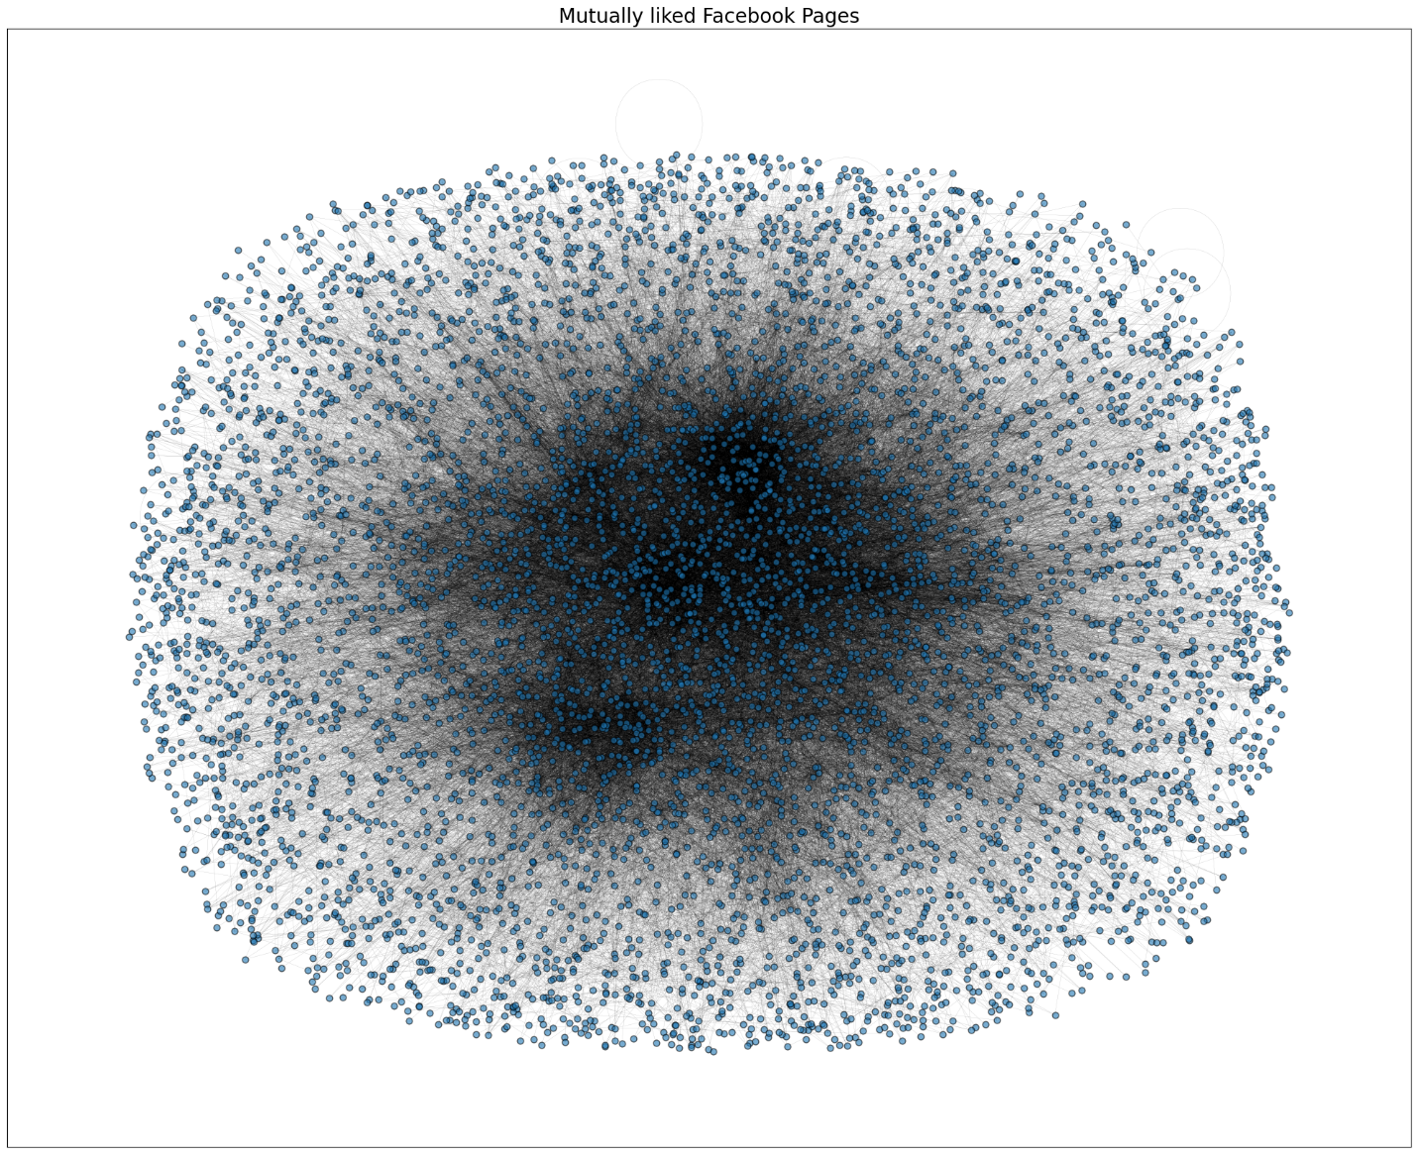

## Degree Distribution

Here is the degree distribution of the real network, Erdos Renyi Network, Barabasi Albert Network and Watts Strogatz Network respectively.

### Real Network

### 

The degree distribution shows us that the low number of nodes have very high degrees while high number of nodes have low degree. Making the distribution highly skewed. This indicates that a small number of high influence pages have a broader base while many pages have low influence. This shows power law distribution.

### Erdos-Renyi Random Network

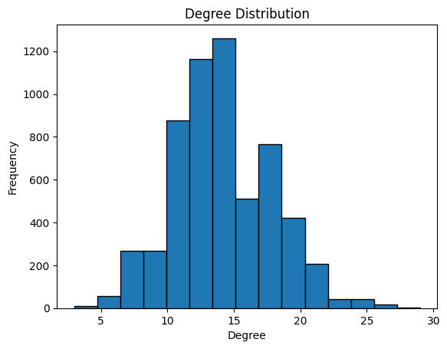

The random network degree distribution shows a normally distributed curve which is not the same as the real network degree distribution.

### Barabasi-Albert Network

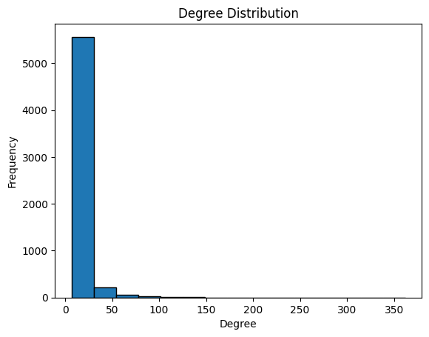

Barabasi- Albert Network degree distribution is very similar to the Degree distribution of the real network as it also satisfies power law test.

### Watts- Strogatz Network

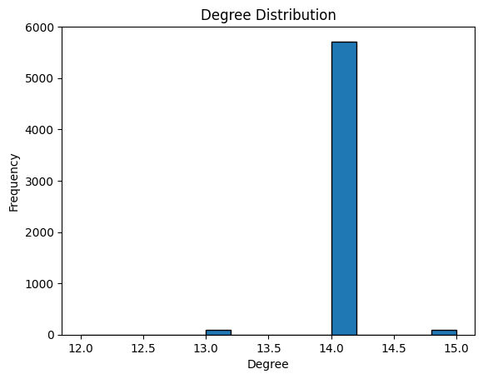

Watts-Strogatz degree distribution is comparatively uniform when compared to the real network.

## Giant component

All the graphs in my visualisation have a single giant component with 5908 connected components. This means that the graph can be traversed fully in all the cases.

## Diameter and Average path Length

|  |  |  |
| --- | --- | --- |
| Networks | Average path length | Diameter |
| Real Graph (Mutually liked FB pages) | 4.66 | 14 |
| Erdos-Renyi Random Network | 3.58 | 5 |
| Barabasi-Albert Network | 3.23 | 5 |
| Watts-Strogatz Network | 17.36 | 38 |

## Clustering and Density

|  |  |  |
| --- | --- | --- |
| Networks | Avg. Clustering Coefficient | Avg. Density |
| Real Graph (Mutually liked FB pages) | 0.385 | 0.00239 |
| Erdos-Renyi Random Network | 0.0023 | 0.00239 |
| Barabasi-Albert Network | 0.01189 | 0.00236 |
| Watts-Strogatz Network | 0.6874 | 0.00237 |

## Degree

### Real Network

|  |  |
| --- | --- |
| Node | Degree |
| 1864 | 323 |
| 4874 | 250 |
| 5800 | 233 |
| 5416 | 229 |
| 1595 | 222 |

### Erdos-Renyi random Network

|  |  |
| --- | --- |
| Node | Degree |
| 443 | 29 |
| 4351 | 29 |
| 5032 | 28 |
| 3413 | 28 |
| 1277 | 27 |

### Barabasi-Albert Network

|  |  |
| --- | --- |
| Node | Degree |
| 0 | 362 |
| 8 | 296 |
| 12 | 287 |
| 10 | 256 |
| 4 | 231 |

### Watts- Strogatz Network

|  |  |
| --- | --- |
| Node | Degree |
| 2634 | 15 |
| 4489 | 15 |
| 302 | 15 |
| 1233 | 15 |
| 913 | 15 |

## Centrality Measures

### **Real Network**

#### Degree Centrality

|  |  |
| --- | --- |
| Nodes | Degree Centrality |
| 1864 | 0.0548 |
| 4874 | 0.0423 |
| 5800 | 0.0394 |
| 5416 | 0.0388 |
| 1595 | 0.0376 |

#### Eigen Vector Centrality

|  |  |
| --- | --- |
| Nodes | Eigen Vector Centrality |
| 5416 | 0.1741 |
| 1595 | 0.1699 |
| 4602 | 0.1684 |
| 4972 | 0.1603 |
| 1414 | 0.1595 |

#### Page Rank

|  |  |
| --- | --- |
| Nodes | Page Rank |
| 3008 | 0.004847 |
| 5800 | 0.004218 |
| 1864 | 0.003773 |
| 4874 | 0.002730 |
| 3576 | 0.002209 |

#### Closeness Centrality

|  |  |
| --- | --- |
| Nodes | Closeness Centrality |
| 5800 | 0.3588 |
| 4081 | 0.3235 |
| 2059 | 0.3205 |
| 4032 | 0.3174 |
| 3387 | 0.3124 |

#### Betweenness Centrality

|  |  |
| --- | --- |
| Nodes | Betweenness Centrality |
| 5800 | 0.2683 |
| 1864 | 0.0555 |
| 3576 | 0.0541 |
| 2900 | 0.0483 |
| 1324 | 0.0451 |

The highest degree centrality is of the node 1864. While node 5800 has high Closeness centrality and Betweenness centrality, which means that they are well positioned to reach other nodes, and they also act as bridges in the network.

### **Erdos-Renyi Random Network**

#### Degree Centrality

|  |  |
| --- | --- |
| Nodes | Degree Centrality |
| 443 | 0.0049 |
| 4351 | 0.0049 |
| 5032 | 0.0047 |
| 3413 | 0.0047 |
| 1277 | 0.0046 |

#### Eigen Vector Centrality

|  |  |
| --- | --- |
| Nodes | Eigen Vector Centrality |
| 444 | 0.02927 |
| 4351 | 0.02858 |
| 3413 | 0.02780 |
| 442 | 0.02674 |
| 1277 | 0.02619 |

#### Page Rank

|  |  |
| --- | --- |
| Nodes | Page Rank |
| 443 | 0.000323 |
| 4351 | 0.000317 |
| 5032 | 0.000311 |
| 3413 | 0.000306 |
| 2847 | 0.000302 |

#### Closeness Centrality

|  |  |
| --- | --- |
| Nodes | Closeness Centrality |
| 444 | 0.3068 |
| 4351 | 0.3062 |
| 3413 | 0.3058 |
| 442 | 0.3040 |
| 3628 | 0.3028 |

#### Betweenness Centrality

|  |  |
| --- | --- |
| Nodes | Betweenness Centrality |
| 4351 | 0.00169 |
| 443 | 0.00167 |
| 3413 | 0.00164 |
| 442 | 0.00151 |
| 5032 | 0.00151 |

In the random network, the node 443 has the highest degree centrality and page rank, The node 444 has the highest Eigen Vector Centrality and closeness centrality. Node 4351 is also an important node as it has the highest betweenness centrality and is ranks second in all other metrics.

### **Barabasi-Albert Network**

#### Degree Centrality

|  |  |
| --- | --- |
| Nodes | Degree Centrality |
| 0 | 0.0613 |
| 8 | 0.0501 |
| 12 | 0.0486 |
| 10 | 0.0433 |
| 4 | 0.0391 |

#### Eigen Vector Centrality

|  |  |
| --- | --- |
| Nodes | Eigen Vector Centrality |
| 0 | 0.24291 |
| 8 | 0.20581 |
| 12 | 0.17357 |
| 10 | 0.15953 |
| 9 | 0.15207 |

#### Page Rank

|  |  |
| --- | --- |
| Nodes | Page Rank |
| 0 | 0.00376 |
| 8 | 0.00303 |
| 12 | 0.00299 |
| 10 | 0.00267 |
| 4 | 0.00241 |

#### Closeness Centrality

|  |  |
| --- | --- |
| Nodes | Closeness Centrality |
| 0 | 0.4603 |
| 8 | 0.4513 |
| 12 | 0.4399 |
| 10 | 0.4344 |
| 9 | 0.4337 |

#### Betweenness Centrality

|  |  |
| --- | --- |
| Nodes | Betweenness Centrality |
| 0 | 0.06694 |
| 8 | 0.04996 |
| 12 | 0.04634 |
| 10 | 0.03929 |
| 4 | 0.03402 |

### **Watts- Strogatz Network**

#### Degree Centrality

|  |  |
| --- | --- |
| Nodes | Degree Centrality |
| 2634 | 0.00254 |
| 4489 | 0.00254 |
| 302 | 0.00254 |
| 1233 | 0.00254 |
| 913 | 0.00254 |

#### Eigen Vector Centrality

|  |  |
| --- | --- |
| Nodes | Eigen Vector Centrality |
|  |  |
|  |  |
|  |  |
|  |  |
|  |  |

#### Page Rank

|  |  |
| --- | --- |
| Nodes | Page Rank |
| 302 | 0.000181 |
| 1105 | 0.000181 |
| 3803 | 0.000180 |
| 549 | 0.000180 |
| 563 | 0.000180 |

#### Closeness Centrality

|  |  |
| --- | --- |
| Nodes | Closeness Centrality |
| 1099 | 0.08248 |
| 502 | 0.08206 |
| 1097 | 0.08191 |
| 508 | 0.08165 |
| 193 | 0.08128 |

#### Betweenness Centrality

|  |  |
| --- | --- |
| Nodes | Betweenness Centrality |
| 502 | 0.11774 |
| 1099 | 0.10287 |
| 193 | 0.09573 |
| 1097 | 0.08585 |
| 508 | 0.08222 |

## Removing Random Nodes

### Real Network

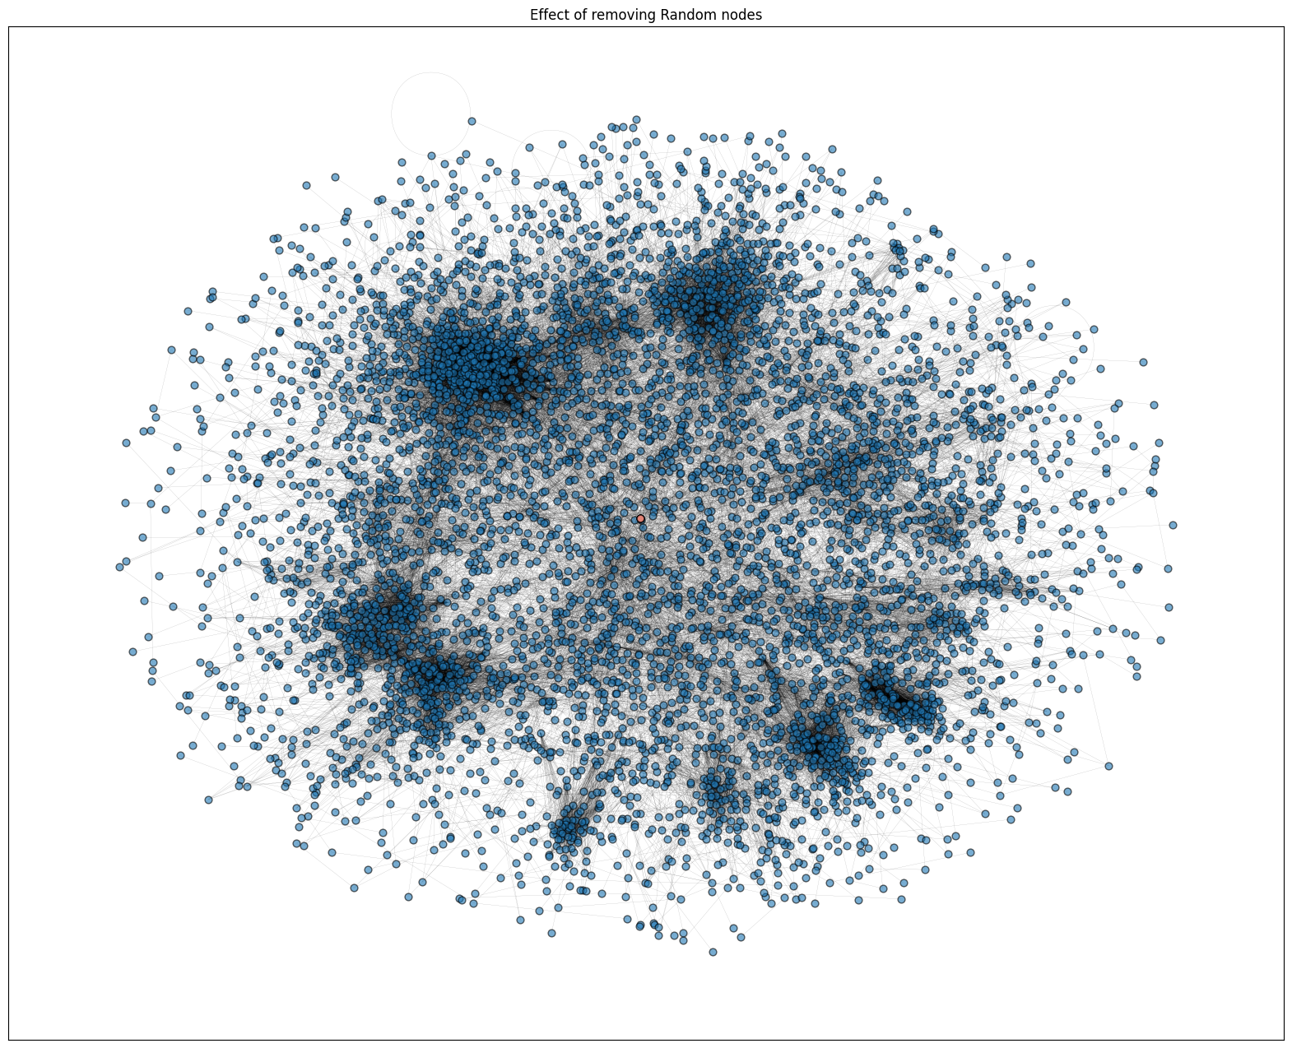

### Erdos-Renyi Random Graph

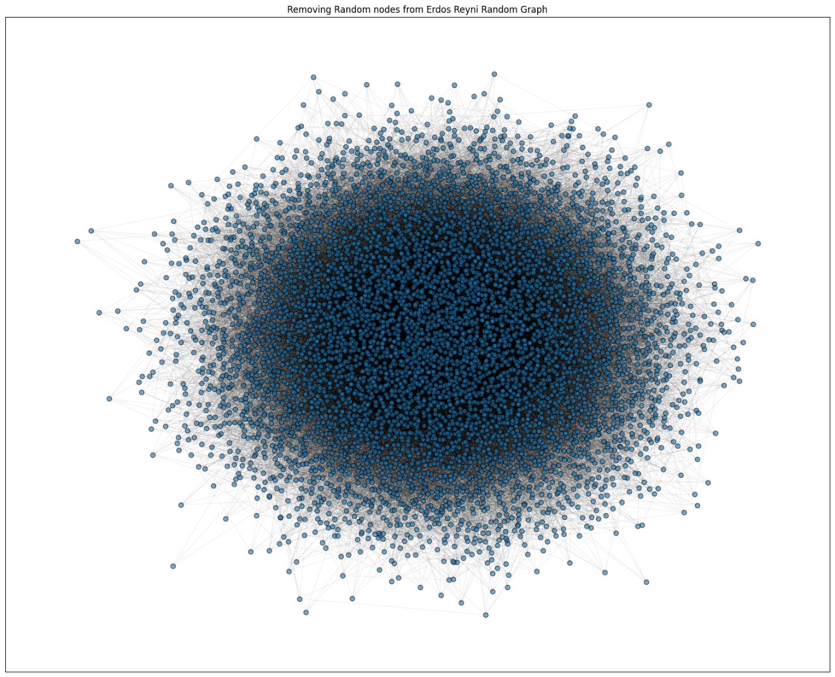

### Barabasi-Albert Network

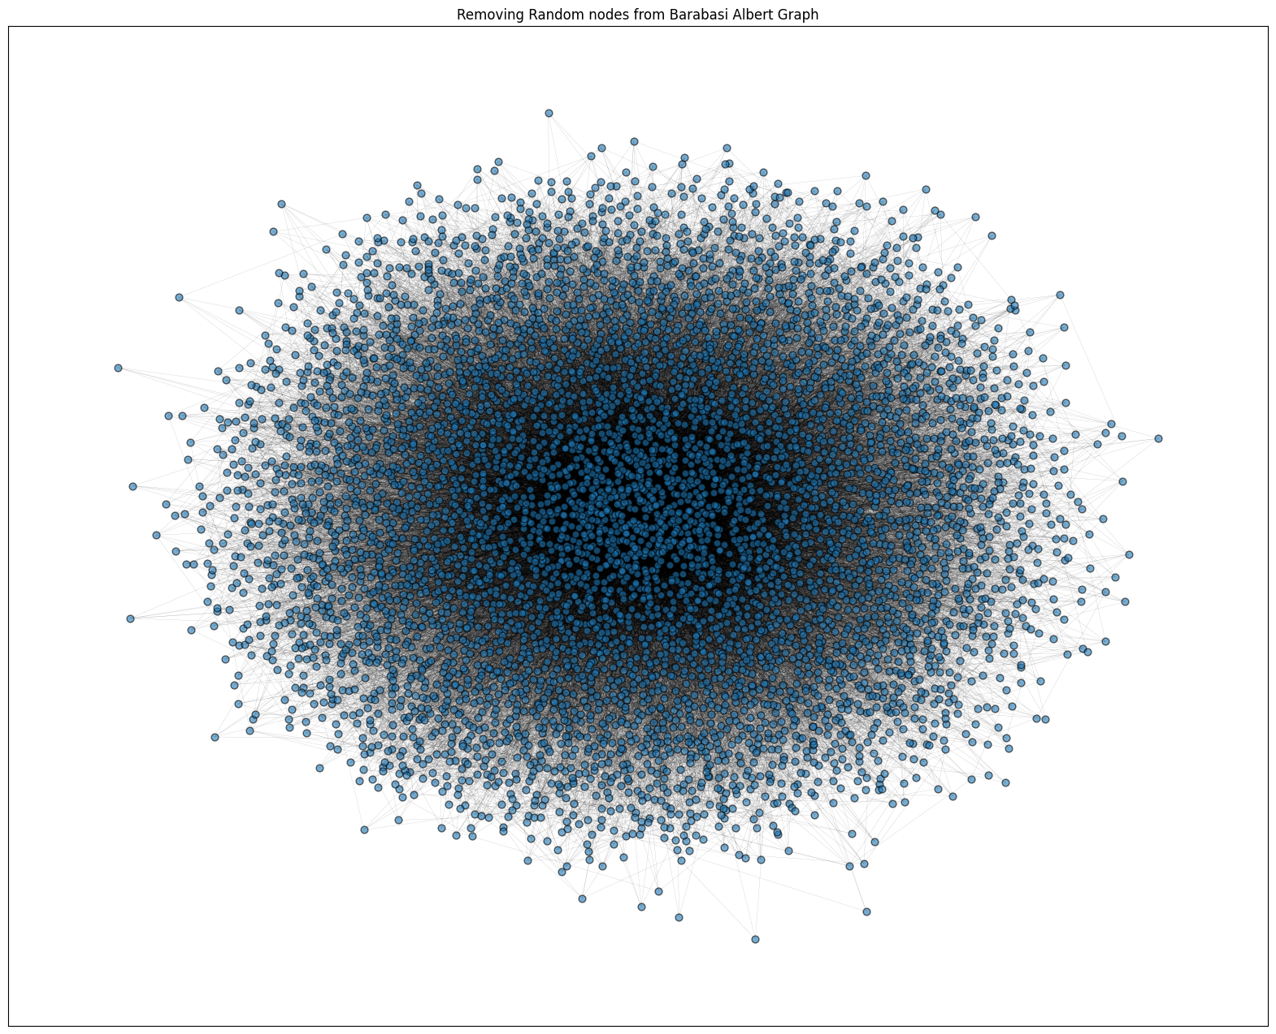

### Watts- Strogatz Network

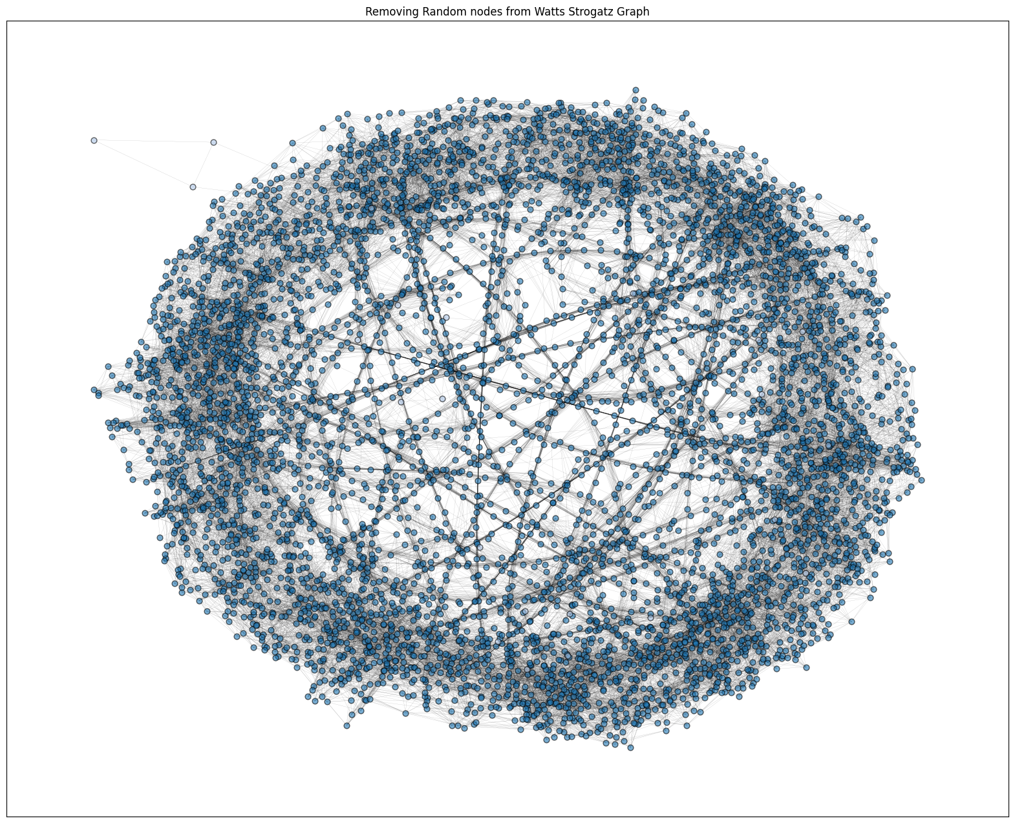

## Removing Nodes with Highest Page Rank

### Real Network

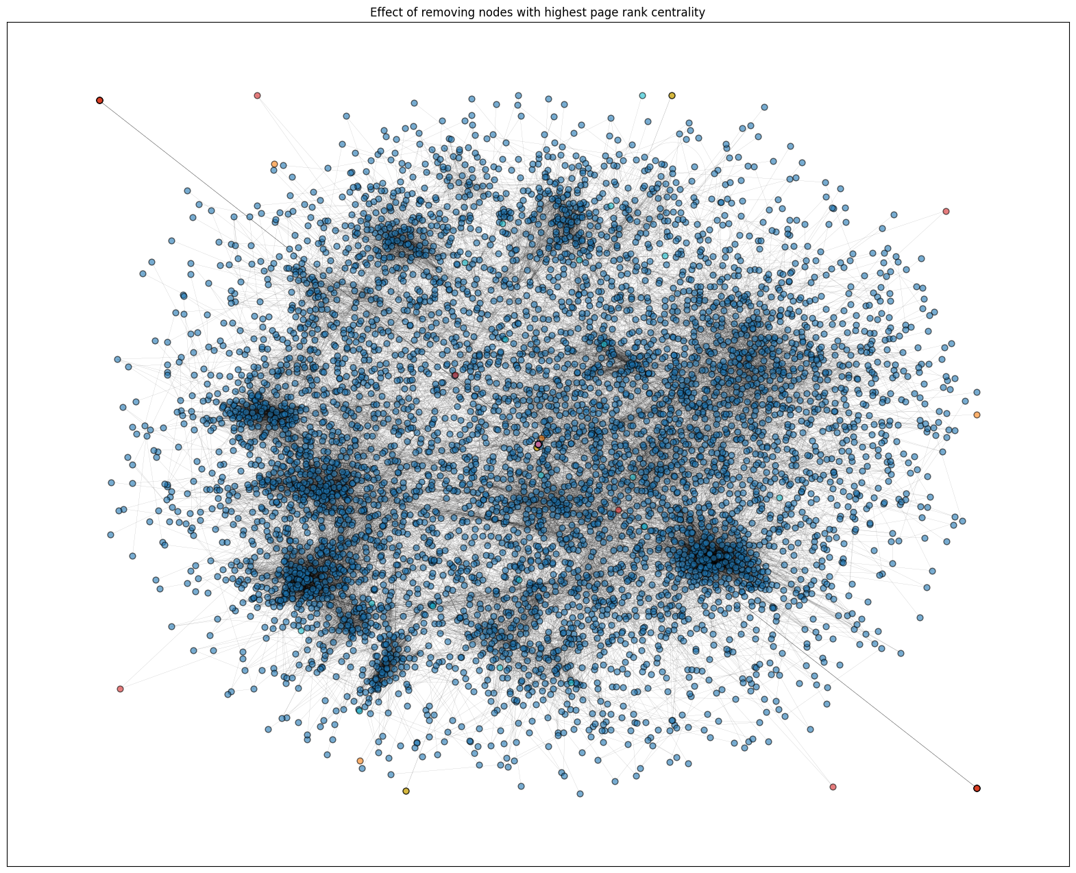

### Erdos-Renyi Random Graph

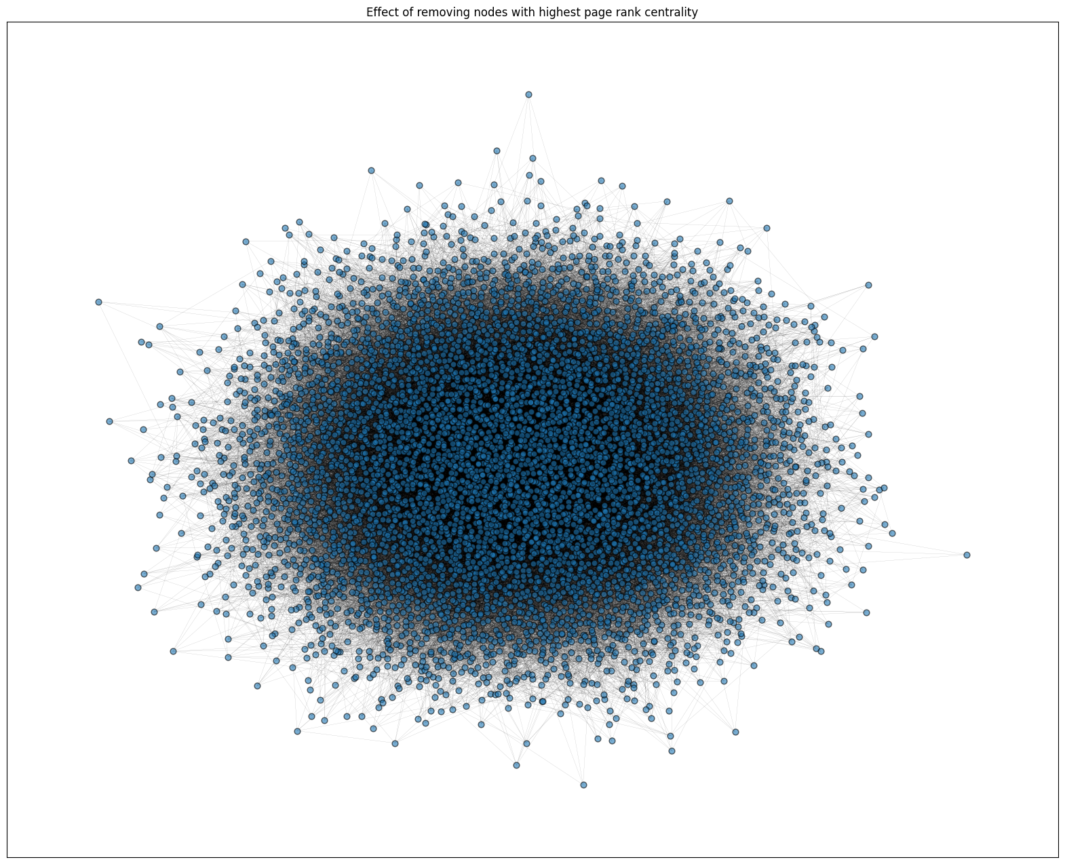

### Barabasi-Albert Network

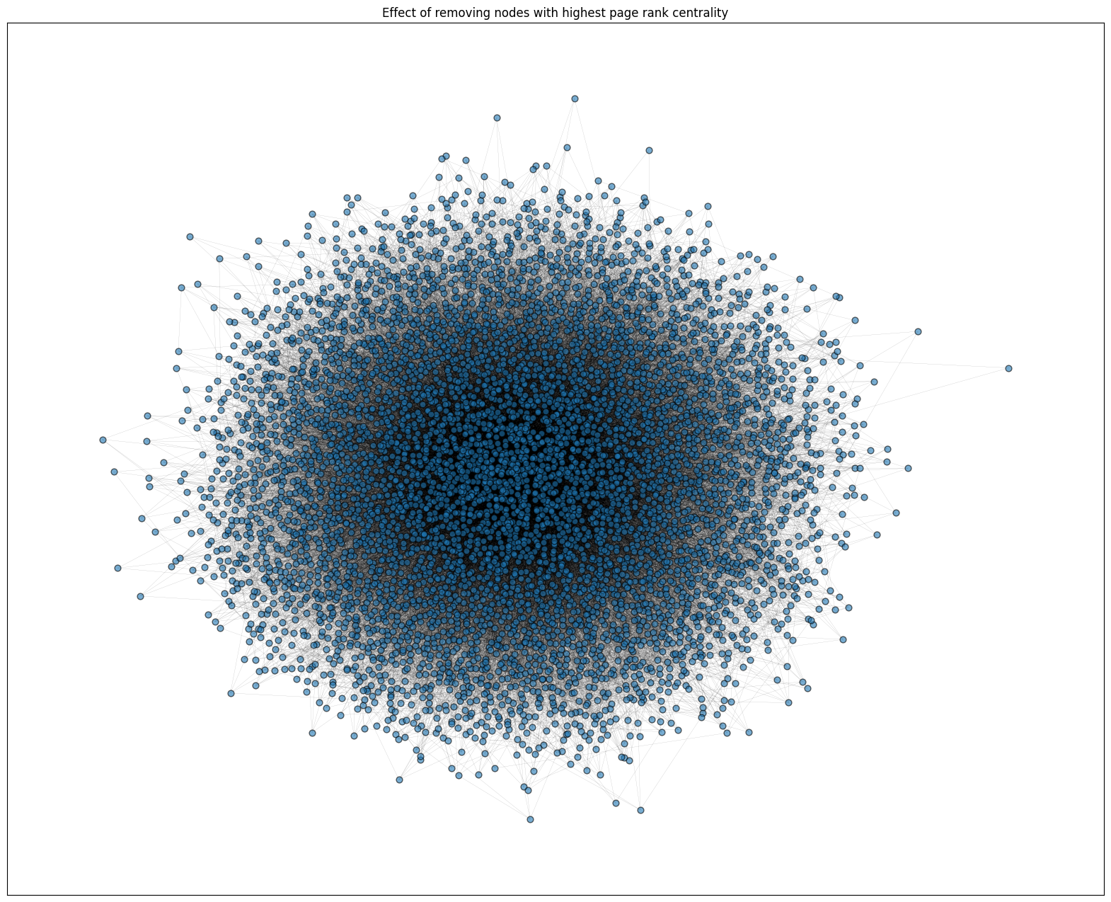

### Watts- Strogatz Network

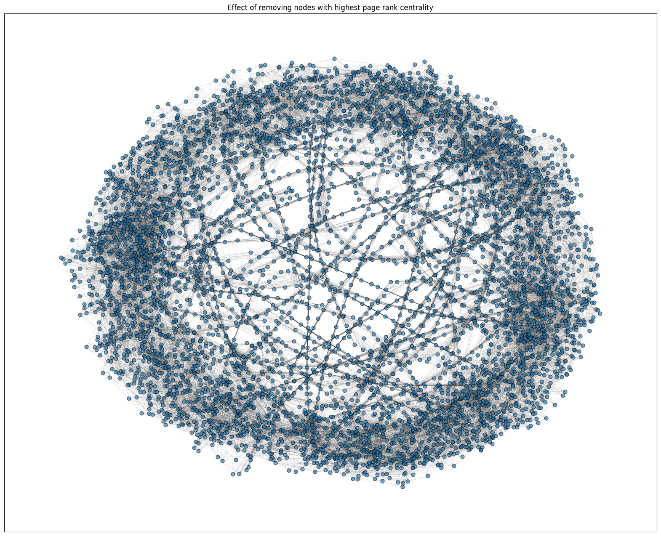

## Community Detection with Louvain Algorithm

The total number of communities detected through the Louvain algorithm are 30.

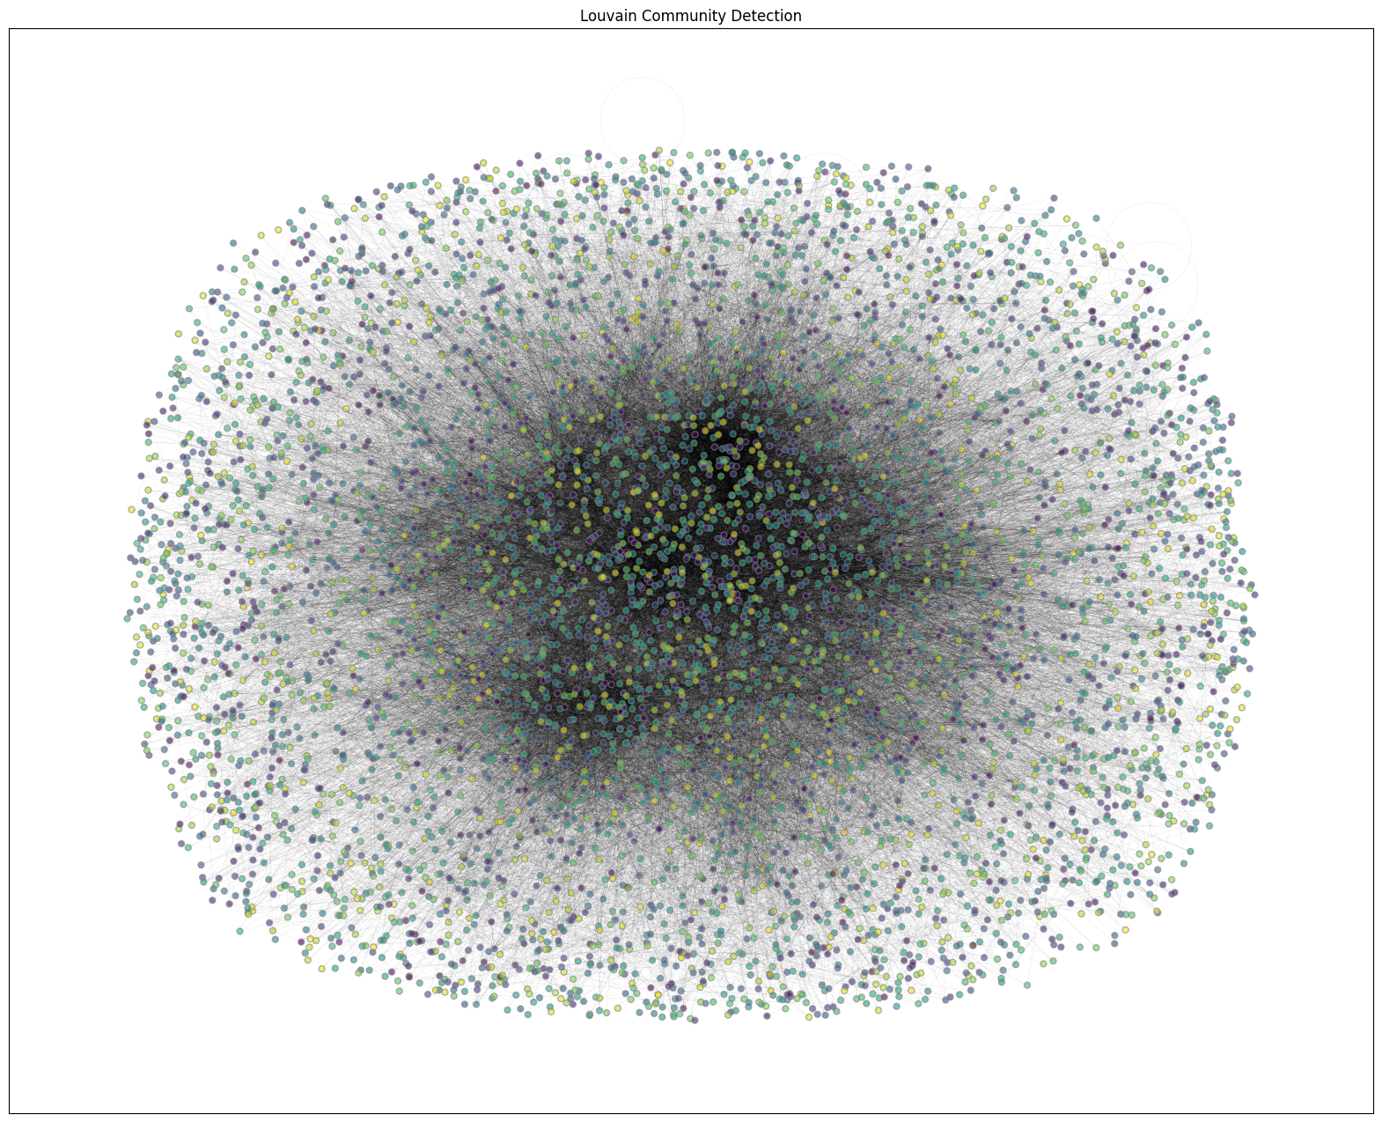

## Linear Threshold Model

We try to find the most influential Nodes through linear threshold model. Initially, few nodes were activated but after iterating, the neighbouring nodes got activated based on their threshold and edge weights.

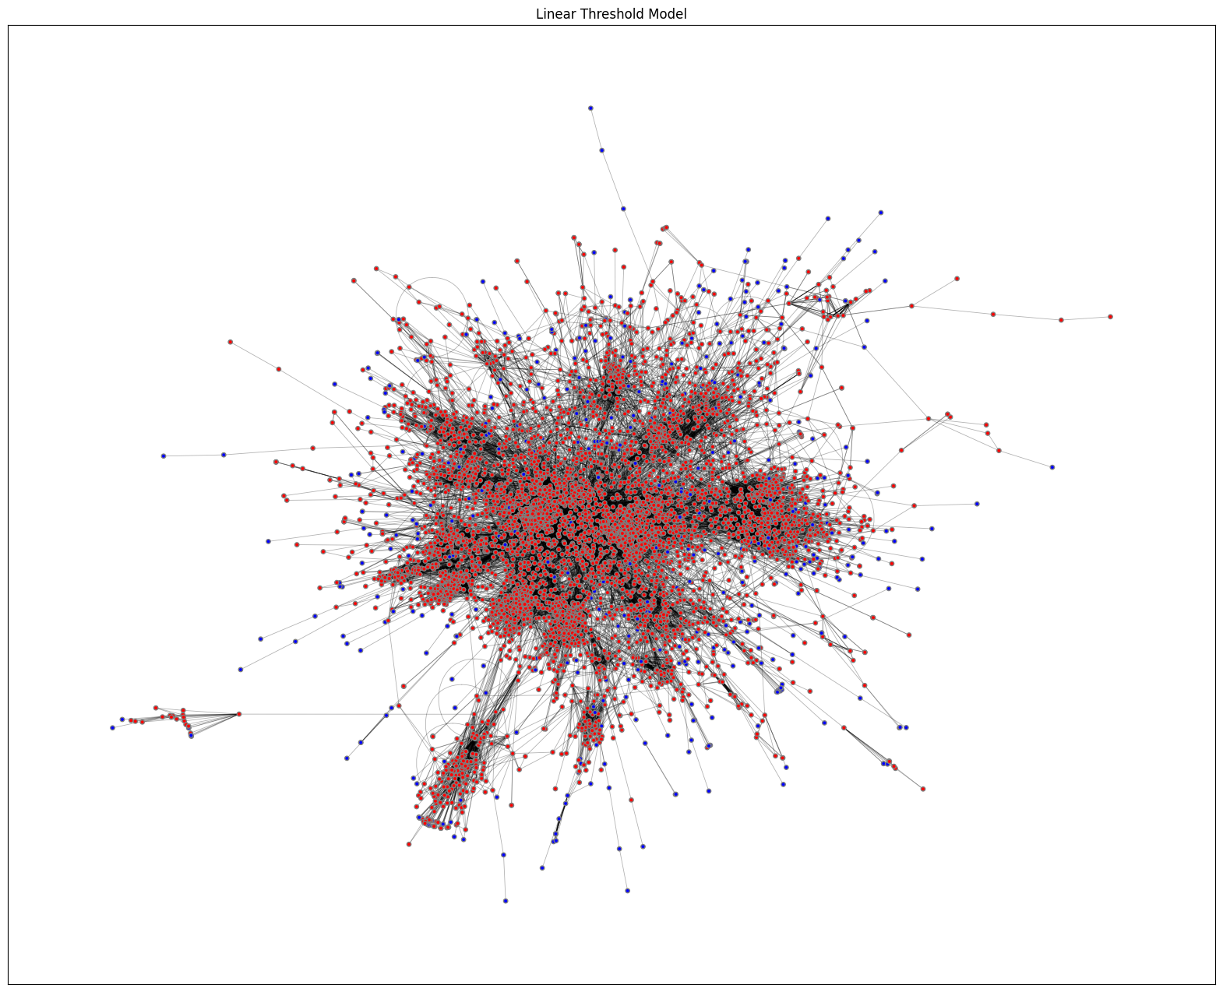

# References

GEMSEC: Graph Embedding with Self Clustering. (2019). In B. a. Rozemberczki, *Proceedings of the 2019 IEEE/ACM International Conference on Advances in Social Network* (pp. 65-72).

Indranil. (2025). *GitHub*. Retrieved from https://github.com/Indranil3001/Indranil3001/tree/Data-Driven-strategic-Decision-making